Ideation Phase: Empathize & Discover
Empathy Map Canvas
Date | 03 October 2026
Developer | Vinay Krishna A K
Project Name | Automated Network Request Management in ServiceNow

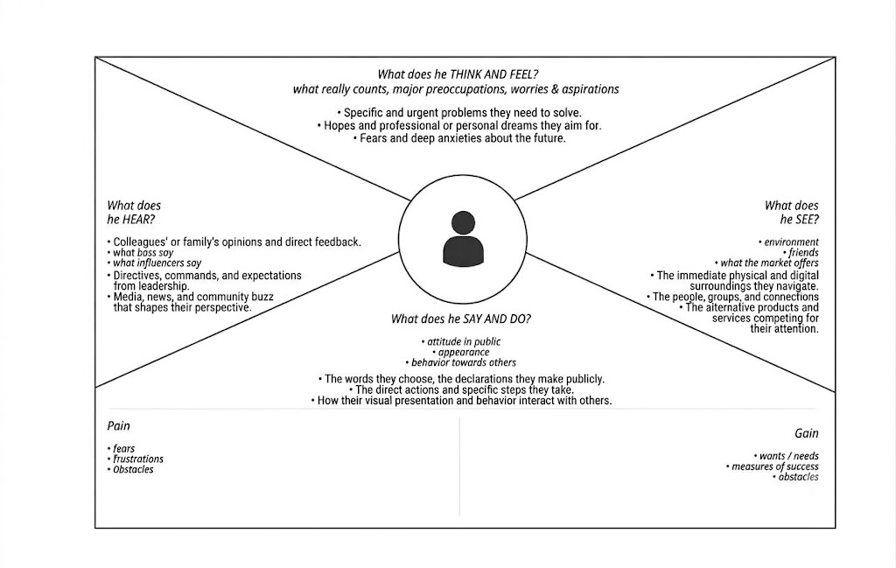

Empathy Map Breakdown & User Analysis
- Think & Feel: Users care about getting access approved on time without administrative hurdles. They feel anxious about unknown request states and seek transparency.
- Hear: They hear feedback that manual requests take days to fulfill, and instructions from IT managers to supply complete connection IDs and security justifications.
- See: They see the centralized Service Portal (/sp) with the Network Request catalog item, dynamic fields changing on selection, and peers waiting on unautomated approvals.
- Say & Do: They fill out network request parameters online, provide justifications, and expect regular email alerts instead of manually chasing support teams.
- Pain (Frustrations): Lack of real-time visibility, form rejection due to missing connection details, and delayed approvals blocking work tasks.
- Gain (Needs & Success): Automated approval routing via Flow Designer, clear dynamic forms with Catalog UI Policies, and automated email notifications at each milestone.

